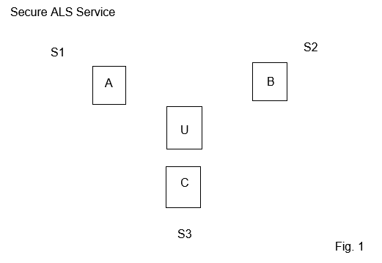

S1-S2 Network Logging (Rule Dump)
S1-S3 Host Logging (Database)
S2-S3 Device Logging (Event)

A Host (Cash Register,
Credit-Card Terminal,
Point-Of-Sale,
Near-Field-Communication)
B App (Login, Card)
C State-Government (Collector-Logger)
Note.
Condition A, B, C Origin Ink-Printer Receipt + Ink-Printer Roll

